CREDIT MANAGEMENT SYSTEM

BY
Aryan Man Singh Pradhan
7-2-282-15-2022 (14891/22)
022BIM015
St. Xavier’s College

A Project Report Submitted to
Faculty of Management, Tribhuvan University
in partial fulfillment of the requirements for the degree of

Bachelor of Information Management (BIM)

Kathmandu
February 2026

STUDENT’S DECLARATION

This is to certify that I have completed the Project entitled “Credit Management System” under the guidance of Er. Rajan Karmacharya in partial fulfillment of the requirements for the degree of Bachelor of Information Management at Faculty of Management, Tribhuvan University. This is my original work and I have not submitted it earlier elsewhere.

SUPERVISOR’S RECOMMENDATION
Signature:
Name : Aryan Man Singh Pradhan
Date
This is to certify that the project entitled “Credit Management System” is an academic work done by Mr. Aryan Man Singh Pradhan submitted in the partial fulfillment of the requirements for the degree of Bachelor of Information Management at Faculty of Management, Tribhuvan University under my guidance and supervision. To the best of my knowledge, the information presented by him in the project report has not been submitted earlier.

Signature of the Supervisor Name: Er. Rajan Karmacharya Designation Date:

APPROVAL SHEET
This is to certify that the project titled Credit Management System submitted by Mr Aryan Man Singh Pradhan has been examined and approved. In our opinion, it meets the required scope and quality standards for a project submitted in partial fulfillment of the requirements for the degree of Bachelor of Information Management (BIM).

Approval Panel:

S.No. | Name | Designation | Signature
1 | Er. Rajan Karmacharya | Project Supervisor
2 | Mr. Ganesh Yogi | Head of Department
3 | Mr Rameshwor Suwal | Internal Examiner
4 |  | External Examiner
5 |  | External Examiner

Date of Defense: 20th February, 2025 Department: Department of Computer Science Faculty: Faculty of Management

ACKNOWLEDGEMENT
I am very grateful to my supervisor, Er. Rajan Karmacharya, for all the help, advice, and support he gave me during this project. His knowledge and well-thought-out advice have been very helpful in shaping and improving this work.

I want to thank Mr. Ganesh Yogi, the Head of the Department, from the bottom of my heart for his guidance and support, which have made both my academic journey and the development of this project much better.

I would also like to sincerely thank our internal examine, Mr. Rameshwor Suwal, for his valuable time, constructive feedback, and support during the evaluation of my project work.

I also want to thank Tribhuvan University for giving me this chance, which has been very important for my personal growth and for getting real-world experience in solving problems.

I want to thank all the faculty members who assisted me with this project, as well as my friends and family for their unwavering encouragement and support.

Mr. Aryan Man Singh Pradhan
14891/22

ABSTRACT
In Nepal, the credit management is still languishing in the manual age. A majority of the small and medium companies are simply tracking the debts and credits in the form of paper, writing ledgers or simply using simple Excel sheets. It is a complete formula to mistakes, obscures the picture, and turns it into a nightmare to establish credit limits, detect bad payments in time, or defaulters before they can do it. These businesses will never escape a financial mishap and poor decision making without automated workflows. That is why there is the Credit Management System (CMS). It is a complete web site that does the heavy lifting automated creditors and debtor trackers, credit limits with blacklist, history of transactions and smooth financial reports. Role-based dashboard allows administrators and users to view credit reports, debt data and blacklist immediately, thereby ensuring that all users have a clear understanding of the money to make smarter decisions.
Technologically the app will be based on a SERN stack, with React.js on the front end, and Node.js, Express on the back end, and SQL Server 2022 as the database. Everything is linked with the help of RESTful API and has a standard three-tier MVC architecture. Security is firm, as well, JWT auth, bcrypt hashing, role controls and client and server input validation. The database is also normalized to 3NF in eight tables to ensure transactions are ACID-compliant and that there is referential integrity. The Tailwind CSS responsive UI and service design based on modules enable the dashboard to retrieve fresh data in less than 200 ms and support up to 250 users at a time, which makes it a scalable and maintainable foundation of the modern credit management.
Keywords: credit management system, debtor tracking, automatic blacklisting, financial reporting, web application

Table of Content
CREDIT MANAGEMENT SYSTEM i
STUDENT’S DECLARATION ii
SUPERVISOR’S RECOMMENDATION ii
APPROVAL SHEET iv
ACKNOWLEDGEMENT v
ABSTRACT vi
LIST OF TABLES ix
TABLE OF FIGURE x
LIST OF ABBREVIATIONS xi
CHAPTER I: Introduction 1
1.1 Background of the study 1
1.2 Problem Statement 1
1.3 Objectives of the Project 2
1.4 Literature Review 2
1.4.1 Overview of Existing Systems 2
1.4.2 Technologies Used in Similar Systems 2
1.4.3 Research and Academic Works 3
1.5 Development Methodology 6
1.6 Scope and Limitation of the Project 7
1.7 Report Organization 8
CHAPTER II: System Development Process 9
2.1 Analysis 9
2.1.1 Requirement Analysis 9
2.1.2 Feasibility Study 11
2.1.3 System Requirements Specification (SRS) 12
2.2.1 System Architecture 12
a. Front-End (React.js): 13
b. Back-End (Node.js & Express.js): 13
c. Database (SQL Server 21): 13
2.2.2 Database Design 13
2.2.2.1 Database Schema 14
2.2.3 User Interface Design 15
2.2.3.1 User Roles: 15
2.2.3.2 Major UI Components: 15
2.2.4 System Flowchart 20
2.2.5 Structured Analysis 21
2.2.5.1 System Overview 21
2.2.5.2 Use Case Model 21
2.2.5.3 Data Flow Diagram 22
2.2.5.4 System Architecture & Design 24
2.2.5.5 Entity Relationship Diagram (ERD) 25
2.3 Implementation 25
2.3.1 Tools and Development Environment 26
2.3.2 System Modules and their Implementation 26
2.3.3 Coding Standards and Conventions 27
2.3.4 Security Considerations 28
2.3.5 Testing and Debugging 29
2.4 Deployment 30
Local Deployment Configuration 30
Planned Online Deployment 30
CHAPTER III: Conclusion and Recommendation 31
3.1 Summary 31
3.2 Conclusion 31
3.3 Recommendations 31
3.3.1 Immediate Production Deployment (Week 9) 31
3.3.2 Short-term Enhancements (1-3 Months) 31
3.3.3 Medium-term Scalability (3-6 Months) 32
3.3.4 Long-term Enterprise Features (6-12 Months) 32
REFERENCES 33
APPENDICIES 35

LIST OF TABLES

Table 1.1 Technologies Comparison of Similar System 2
Table 1.2 : Report Structure Overview 8
Table 2.1 : Functional Requirements Table 9
Table 2.2: Use Case for User Login 10
Table 2.3: Use Case for Add Creditor/Debtor 10
Table 2.4: Use Case for Blacklist Debtor 10
Table 2.5: Use Case for Generate Report 10
Table 2.6: User Roles and Permission 11
Table 2.7 Non-Functional Requirements Table 11
Table 2.8 Hardware Requirements 12
Table 2.9 Software Requirements 12
Table 2.10: Database Schema 14
Table 2.11: Tools and Development Environment 26
Table 2.12: System Modules and their Implemenation 26
Table 2.13: Credit Management System Test Case Samples. 30

TABLE OF FIGURE

Fig 1.1 : Iterative Waterfall Model for Credit Management System 7
Fig 2.1 Registration Process 15
Fig 2.2 Login Process 16
Fig 2.3: Add Debtor with Products 17
Fig 2.4: Update Debtor 18
Fig 2.5: Delete Debtor 19
Fig 2.6: Dashboard Statistics 19
Fig 2.7: Flowchart of Credit Management System 20
Fig 2.8: Use Case Diagram of Credit Management System 21
Fig 2.10: Level 1 DFD 23
Fig 2.11: System Architecture & Design 24
Fig 2.12: Entity Relationship Diagram 25

LIST OF ABBREVIATIONS
BIM Bachelor of Information Management
CMS Credit Management System
SERN SQL Server, Express.js, React.js, Node.js
MVC Model View Controller
3NF Third Normal Form
ACID Atomicity, Consistency, Isolation, Durability
JWT JSON Web Token API Application Programming Interface
RESTful Representational State Transfer UI User Interface
CRUD Create, Read, Update, Delete
CSS Cascading Style Sheets
SQL Structured Query Language
DFD Data Flow Diagram
ERD Entity Relationship Diagram
SRS System Requirements Specification
UAT User Acceptance Testing
IDE Integrated Development Environment
HTTP/HTTPS Hypertext Transfer Protocol / Secure
SSL Secure Sockets Layer
SME Small and Medium Enterprise
PDF Portable Document Format
URL Uniform Resource Locator
ENV Environment (as in .env configuration file)
MVC Model View Controller
KYC Know Your Customer

CHAPTER I: INTRODUCTION

1.1 Background of the study
The management of credit is one of the foundations of the money management of people and companies today. When you manage creditors and debtors, then you will ensure that you pay bills on time, prevent bad debts and maintain a healthy cash flow. However, the old-fashioned approach continues to affect the majority of the Nepali businesses: paper records, handwritten notes, simple spreadsheets. They are slow, prone to errors and partially a black box as far as transparency is concerned.

In the new digital era, any company and person should have a sound, computerized system in place to ensure that the flow of credit is not affected. A Credit Management System is like a hub: it keeps a record of who owes whom and credit limits and automatically reports on the defaulting of people. In addition, it is capable of generating reports and maintaining data neat, and this assists decision makers to make intelligent financial decisions.

These are the pain points that our Credit Management System Application addresses. We are developing an easy to use web-based application that will automate credit monitoring and management. The goal? Automate operations, reduce errors and modernize credit information management in the 21st century.

1.2 Problem Statement
Credit dealings are still stored in clip boards and handwritten journals, or under a basic spreadsheet, in a lot of SMEs and among ordinary users. The fact that manual workflow is a home to human error, incorrect data and the age old I can’t keep up with everybody issue is heightened by the fact that you have numerous debtors and creditors simultaneously. When you lose a point of reference to know what is owed, the overdues grow invisible, the restrictions become difficult to enforce, and the bad debtors will show up in business like financial meltdowns, and headaches.

The decision makers will not see the entire picture of the credit situation of the company without automation and reporting. The manual setup, to be sincere, completely bypasses automated blacklisting when a person exceeds the limit, and there is lack of real time tracking as well. This puts the company in a risk position indeed in the long run and makes it hard to detect trouble early. As such, we definitely require a robust, stable, automated Credit Management System. This tool should not just handle the creditors and debtors but should automatically identify the defaulters and come up with a report that will provide us with a better understanding and assist us in making wiser decisions.

1.3 Objectives of the Project
The main objectives of this project are as follows:
- To develop a web app which tracks data of all creditors and debtors and blacklist them based on their credit limit.
- To be able to generate financial report and to list out all debtors and creditors

1.4 Literature Review

1.4.1 Overview of Existing Systems
There are many credit and financial management systems out there, the only difference is that there are many systems in the world such as QuickBooks, Tally, and Zoho Books. Although they offer good accounting and credit management services, cost and complexity can be a very big obstacle. It is particularly so with small and medium size enterprises in Nepal, which might not fit well in these platforms. As a result, a lot of local companies continue to use outdated practices or even the use of a basic spreadsheet that, unfortunately, does not provide any automation or blacklisting features.

1.4.2 Technologies Used in Similar Systems
Most modern credit management and accounting applications are developed using:
Table 1.1 Technologies Comparison of Similar System
System/ Project | Programming Language | Database | Framework | Notes
Cashix (instant micro‑loan app) | Frontend / Mobile: React Native + TypeScript; Backend: Java + Spring; ORM: Hibernate | MySql | Java | It also uses Docker, Kubernetes for deployment, and integrates with third-party services (KYC, card verification). (NerdySoft)
Credit Scoring SaaS (by Itexus) | Ruby on Rails | MySql | Angular 8 | It separates the statistical / scoring module (exposed via APIs) from the web UI, supports horizontal scalability. (Itexus)

1.4.3 Research and Academic Works
Campbell et al., (2022) identified a sample of credit card holders who had defaulted in more than thirty days, thus the sample is actual representation of a mixture of credit scores. It was about a digital repayment reminder that was transmitted via an application or an internet site. This was carried out in 2016 and the location was the online infrastructure of the credit provider. In essence, the researchers were interested in whether such reminders could reduce the excessive price of credit card nonpayments and reduce the additional expenses that lenders are required to hold. When they defied the extent of working of the reminders, the figures indicated an evident improvement of repayment percentage and rates among those with a better credit score, and not much difference among the poorer ones. The percentage point increase in the amount of treated debtors (64.3 vs. 61.9) paying all the debt off in this cycle was 2.4, and the impact was as high as 2.7 percentage points in debtors who actually took the reminder. Better still, the reduction in delinquency continued at least one year, a demonstration of a benefit that is persistent.

Wang, (2021) This paper examines the players within the dynamic and volatile Chinese consumer finance market, which is characterised by the runaway credit, swindles, and unfair competition. My key question that I am addressing is how to correct these issues, in particular, how we can better manage risk by making use of big-data credit scoring. The study concentrates on the contemporary years in the Chinese consumer finance market. I am doing so due to the need to have sustainable growth, early warning on risks, and to check reckless lending. Finally, the paper demonstrates that big data enhances risk management: the approvals get faster, all-in-one credit databases are created, high-score clients can be processed faster, staff workloads reduce by 20, and risk prediction accuracy increases by 16.

Alfonso-Sánchez et al., (2024) The paper will explore credit-card users in Latin America who will access a super-app, which integrates other functions with financial services. Specifically, we consider how reinforcement learning could make it possible to automatize the process of deciding whether a customer should have an increase in credit-card limit or not. The time-frame and geographical scope of our study is consistent with the recent literature that addresses the same banking issues within a super-application ecosystem located in Latin America. Their primary aim is to balance competing targets- to increase portfolio returns and reduce provisions and go from expert-driven strategies to objective and data-driven decision-making protocols. We have made this transition as easy as possible to the stakeholders. In order to arrive there, we formulated the problem as an optimisation problem, used offline learning methods on past data, and developed a Double-Q learning agent that would do better than current strategies. The findings affirm that reinforcement learning could be efficient in the banking environment in the real world, although the addition of alternative data to determine the balance did not necessarily result in an improved performance.
.
Bakoben et al., (2020) The current research focuses on individuals that have credit card accounts today and their behaviours are the foundation of risk assessment. This paper proposes a novel measure of the differences between statistical model parameters by applying the cluster analysis of account activity. The methodology will assist in maintaining advanced analytics within the management of bank credit risks. The key point is to make the process of risk evaluation more accurate so that the policy implementation can be more straightforward, and the development of financial instruments can be more efficient.

Yoganandham, (2025) This paper examines the attempts by individuals to achieve long-term financial security and self-reliance. We are breaking down the major strategies which assist in hitting that target-budgeting, saving, investing early, managing debt and putting it all to a sound financial plan. The backdrop? We want to provide people with the means to be smarter in their money decisions, to move resources around in a smart way to save the fortune of future generations and their own. In a word, we are plotting out how to achieve these goals: closely monitoring income and costs, establishing a savings cushion, taking the lead in investments, carrying out debt responsibly, and integrating all that into a single coherent plan, which elevates resilience via economic fluctuations and makes people prosper.

Albanesi & Vamossy, (2019) This project is aimed at consumers whose credit default risk has to be forecasted. In fact, I have constructed a deep learning model that is directed towards predicting consumer default. The experiment is currently located, in real financial institutions, namely in the credit risk assessment. The three primary reasons behind this study are to enhance prediction than can be achieved by using the traditional credit scoring models; provide insights which can be of help in shaping the policy; and reduce the adverse influence of default on the borrower, lender and the entire financial system. It is a deep learning model, which uses the same data as traditional ones, but is much easier to interpret, can be applied to more borrowers, and can capture systemic risk changes fairly well.

Le et al., (2023) In the process of analysing international data, our students made an attempt to determine such things as what actually drives the growth of digital credit. We discovered that the anti-money laundering regulations influence the fintech credit the most, and innovation capacity influences it the most, whereas innovation is the most critical factor with bigtech credit. It also provides valuable information to policymakers and financial institutions to make responsible the development of digital credit.

Bhatt et al., (2023) states that this investigation utilizes cross-national data spanning from 2013 to 2019 to analyze the primary determinants of digital credit expansion, employing ordinary least squares regression with fixed effects. The results indicate that regulations concerning anti-money laundering and counter-terrorism financing, a nation's innovation capacity, and its financial development exert substantial influence on fintech credit; furthermore, innovation capacity is especially critical for bigtech credit.

Jakubik & Teleu, (2025) stated out BMA is more effective than the conventional Single-Equation Models (SEM). The BMA has the advantage of allowing the different economic situations and industry statistics to be combined in a unified fashion, which makes it stable in the face of extreme changes. This is what makes BMA especially appropriate to those small economies as Malta, which are quite vulnerable to international shocks. As a result, BMA is a useful stress-testing tool and helps in estimating the right reserves levels. Overall, more flexible models exist like the BMA that have significant advantages in this situation.

West, (2021) stated this work basically defines the economic advantages gained by bigger IT systems, examining every bread and butter in terms of the elementary economics. The authors have described certain transaction hacks that result in the cost reduction, and particularly, the savings will enhance disproportionately as the system grows. The study goes further to explain the consequences of controlling IT operations, either by outsourcing or in-house maintenance based on the empirical narratives which have been based on technology intensive sectors. Wraps up with ideas for future work on size vs variety savings and how buying strategies shake up company structure.

Lessmann et al., (2024) stated out since the time when Baesens et al. (2003) benchmarked classification algorithms to credit scoring in the Journal of the Operational Research Society, many years have elapsed before the scorecard prediction methods were of interest to many. What do we investigate? Our contribution to this study is new algorithms (e.g., gradient boosting, deep learning) versus state-of-the-art baselines, new developments in learning methods, new performance metrics, and comparisons of classifiers. When? In the context of the fast evolution of data mining since 2000s. In OR banking forecasting benchmarks. To determine whether greater accuracy results in managerial value, and the way the evaluation varies with traditional and novel measures, useful to practitioners and offer academics a new benchmark. Through the multidimensional tests of empirical updates. We have knowledge that informs credit rating experts and researchers.

J.Oladuji, (2021) Stated SMEs are major contributors to economic growth, innovation, and employment in the world and yet they find it difficult to access traditional financial services due to lack of credit history, informality and the perceived risk. This paper examines opportunities of AI to change the nature of modeling SME financial performance, particularly in payment systems and credit scoring. With alternative data sources (e.g., transaction histories, utility bills and behavioral indicators), which we use to assess the different AI techniques- machine learning, natural language processing and anomaly detection- we give a more refined credit risk assessment and allow real time payment processing and smart routing, detection of fraud, and optimization of cash-flows.

Bitetto et al., (2023) This paper compares two approaches to estimating credit risk in small and medium-sized businesses (SMBs) a classic parametric ordered probit model and a non-parametric machine-learning model based on historical random forest (HRF). We are using both models with an original dataset of granular, firm-level quarterly data of 464 Italian SMBs (2015-2017), provided by an international insurance company and an Italian investment bank. The findings indicate that the HRF model outperforms the ordered probit in predictivity, and machine learning can play an invaluable role in the determination of SMB credit risk in the presence of high information asymmetries. Shapley values can also be used to explain which variables are the most important, enhancing the level of interpretability of the model. In general, our results provide the validation of the idea that advanced estimation methods can be applied to robust SMB risk prediction even in the settings of limited data.

Yun, (2025) Stated with the help of this assignment, I can track the evolution of credit risks management in the digital age with the large influence of big data, artificial intelligence, machine learning, and blockchain. The case studies indicate how other industries (i.e. Banks, fintech companies) are accelerating their adoption of these technologies. I would say in future that good governance structures are essential to keep the implementation of digital apps to be ethical and fair, which would eventually enhance our credit risk management.

Nohuddin et al., (2025) Stated that FinTech and analytics data collection in point of accuracy, inclusiveness, and risk management works better than the traditional models. In my mixed-methods research, it is hoped that I will compare the machine learning algorithms used by traditional banks and FinTech startups. My basis of performance measurement will be quantitative measures and the qualitative information will be obtained by conducting interviews with industry professionals. Conventional organizations tend to base their decision-making on historic financial information, but FinTech firms access other sources, such as transaction patterns, with more sophisticated analysis to enable them to make quicker and more inclusive decisions.

1.5 Development Methodology
The Iterative Waterfall model includes the traditional sequential stages that an academic would consider to be important such as requirements, design, coding, testing and demonstration, but includes quick fix loops that are fast and enable certain changes. I find this style actually quite helpful when doing a uni project since you can allow the change of advisors, any bugs found, or a group member dropping out and your 100 page report is not scuttled like in the standard waterfall disasters when a single bug missed the deadline and made your whole semester. It is structured enough to amaze the examiners and yet free enough to allow very real student behaviors such as late feedbacks, scope creep or viva panic, opening the path to getting the A-grade without the pressure. This technique will improve the gradual refinement of the system to make it really satisfy user requirements like credit tracking, black listing and reporting. Besides, the Iterative Waterfall Model reduces risks as it validates the system on a regular basis.

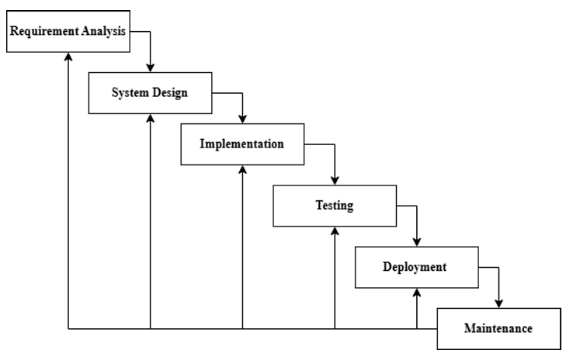
Figure 1.1 : Iterative Waterfall Model Nohuddin et al., (2025)

1.6 Scope and Limitation of the Project
The Credit Management system is in effect central financial hub, by consolidating the data about the creditors and debtors in one interface. All the transactions are shown in real-time on an intuitive dashboard, delinquent balances are displayed prominently, and entities which default on payments are automatically filtered out so that effort is no longer required to collect them. Single-Click export to Excel allows making a trend analysis and offering valuable proof to show it to any stakeholder or academic supervisor. Strong authentication can guarantee that all the information is safely encrypted and controlled access is limited. It is also especially fit to small businesses, startup sectors, family owned businesses or university projects that do not involve a complex enterprise system and thus need to be tracked easily through credit.
The limitations of credit management systems are:
- They have a web-based structure that can only be effective with a stable internet connection.
- Moreover, they are not programmed to fulfill the sophisticated needs of big organizations that require sophisticated forecasting and analytics.
- The reporting capabilities are basic, and the system does not have the implementation of the AI-based predictive credit scoring.
- The quality of the system will depend on the accuracy and promptness of the data that is entered by the user and this is important in order to obtain reliable reports and desired results.

1.7 Report Organization
Table 1.2 : Report Structure Overview
Chapter No. | Chapter Title | Description
Chapter I | Introduction | This introductory chapter furnishes contextual background, the problem statement, project objectives, a review of relevant literature, the employed methodology, the project's scope, and the report's organizational framework.
Chapter II | System Development Process | This chapter examines the system analysis, design, requirements, feasibility, and the system architecture.
Chapter III | System Implementation | The ensuing sections will elucidate the employed tools and frameworks, alongside the development methodology, encompassing both coding practices and database architecture.
Chapter IV | Testing and Results | The testing methodologies, the evaluation procedures, and the system's operational performance.
Chapter V | Conclusion & Recommendations | This chapter summarizes the project's findings, discusses the difficulties encountered, and suggests ways to improve future work.
References |  | The References section provides a complete list of all sources, journals, and materials cited in this report.
Appendices |  | This section includes screenshots, code snippets, and other supporting documents.

CHAPTER II: System Development Process

2.1 Analysis
This was simply the first evaluation of the Credit Management System, where the weaknesses of the present manual credit management practices were identified and how to automatize it with the help of a web-based platform were calculated. Many small and medium-sized enterprises (SMEs) languish in the inability to maintain accuracy and consistency when they archive creditor and debtor financial records in registers, ledgers or spreadsheets. As an effort to address such issues, we organized a requirements analysis that involved consultants to assess the current financial management systems, practices that are currently being practiced, and delved into the needs of users. The findings of the study basically informed us that we require a system that would be able to monitor and document credit transactions, automatically disqualify those who default and generate a systematic financial reporting. This knowledge was then employed in the development of the system design and implementation, as they were employed to develop both functional and non-functional requirements.

2.1.1 Requirement Analysis
A meticulous analysis of the requirements was conducted in order to fill the gap between the current manual processes and the proposed automated system. Among the core requirements were proper documentation of the creditor and debtor information, developing mechanisms to enforce credit limit, automation of blacklisting procedures and production of relevant reports. Further security measures and ease of use were also mentioned as the critical factors.

2.1.1.1 Functional Requirements
The following are the main core functions of the expected system:
3 Table 2.1 : Functional Requirements Table
Requirement ID | Requirement Description | Example/Details
FR1 | User Authentication & Role Management | You would need to log in to access the features. The admins are able to do all of it; ordinary users can only control their information.
FR2 | Creditor & Debtor Management | Managing Add, edit, or delete creditor/debtor records- names, contacts, amounts owed and credit limits.
FR3 | Transaction Recording | All credits issued, repayments, or changes of balances are automatically logged.
FR4 | Blacklisting Module | In case a person reaches their credit limit, the system puts a flag and restricts the person
FR5 | Report Generation | Generates creditor report, debtor report, and transaction history.
FR6 | Dashboard & Notifications | Summarizes the total creditors, debtors, overdue accounts, and generates alerts about the missed payments

2.1.1.2 Use Case Scenario
A use case scenario is simply a demonstration of a sequence of interactions and activities between the system and a user. It is comparable to a single potential route of a use case, which results in a goal. The following tables give the use cases of the system.

4 Table 2.2: Use Case for User Login
Use Case | User Login
Actors | Admin, User
Preconditions | The user should be a registered user in the system.
Steps | - Enter username & password  - Click login  - Network audit credentials  - Navigate to proper dashboard
Postcondition | User successfully logs in or receives an error message.

5 Table 2.3: Use Case for Add Creditor/Debtor
Use Case | Add Creditor/Debtor
Actors | Admin/User
Preconditions | User should be logged in.
Steps | - Go to Manage Creditors/Debtors  - Enter details with its product  - Save record  - System validates and stores data
Postcondition | New creditor/debtor successfully added to database.

6 Table 2.4: Use Case for Blacklist Debtor
Use Case | Manage Orders
Actors | System (Automated), Admin
Preconditions | Debtor exceeds credit limit.
Steps | - Checks balance in the system  - Mark to show a flag debtor if overdue exceeds limit  - Add to blacklist  - Notify Admin
Postcondition | Order status changed, and customer notified.

7 Table 2.5: Use Case for Generate Report
Use Case | Track Order Status
Actors | Admin/User
Preconditions | User should be logged in.
Steps | - Navigate to Reports section  - Select report type (creditor, debtor, blacklist, transactions)  - System generates PDF/Excel  - Display or download report
Postcondition | Report successfully generated.

2.1.1.3 User Roles & Permissions
The system characterizes various categories of users that have a certain role and access level to make things safe and effective:
8 Table 2.6: User Roles and Permission
User Role | Permission
Admin | Full access to manage users, creditors, debtors, blakclist, and reports. Can view all data and system logs.
Manager | Can add and edit debtor, creditors, blacklist and reports.
User | Can view reports related to manager and admin account.
System | Monitors credit limits, flags defaulters, and updates blacklist status automatically.

2.1.1.4 Non-Functional Requirements
Non-functional requirements inform us about how the system is to be working such as its boundaries and functional features. They pay attention to such quality features as performance, usability, and compatibility. These are the requirements which outline the behaviour of the system. The online order management system has the following non-functional requirements:
9 Table 2.7 Non-Functional Requirements Table
Requirement ID | Requirement Description | Example/Details
NFR1 | Usability | Interface should be easy and user friendly to SMEs.
NFR2 | Security | Security Data should be authenticated and authorized.
NFR3 | Performance | System shall be able to cope with transactions and produce reports in a short time.
NFR4 | Scalability | Should be able to expand number of creditors and debtors.
NFR5 | Compatibility | This should be compatible with modern web browsers and mobile-friendly interfaces.
NFR6 | Maintainability | System must be easy to update and modular.

2.1.2 Feasibility Study

- Technical Feasibility: The system is developed using open-source technology. React.js is used as the front-end, and Node.js/Express as a back-end, and MySQL as a database. These options are good and the user base is vast as well as the documentation and this ensures that the technical side is well sound.
- Economic Feasibility: Economic feasibility is a good strength. Since the system is based on the open-source technology, hardware and internet access are the primary costs whereas the developers time costs are minimal.
- Legal Feasibility: The system is legally compliant with the common data protection procedures. But when it is applied commercially, then we will have to deal with the laws of data privacy and online transactions.
- Operational Feasibility: Operationally, the application is designed to be simple and user friendly so that small and medium sized businesses, not mentioning individuals, can use the application without a required technical understanding.
- Schedule Feasibility: The schedule is also feasible. The Waterfall model of iterations provides a methodological structure of development and allows refining the adjustments in an iterative manner required, thereby providing the plausibility of the project schedule.

2.1.3 System Requirements Specification (SRS)
The specifications listed below outline the recommended and minimum hardware and software requirements to achieve the optimal performance, scalability and security. To recap, the elements listed in this section are the much-needed requirements to be operational.
10 Table 2.8 Hardware Requirements
Category | Minimum | Recommended
Processor | Intel Core i3 | Intel Core i5 or higher
RAM | 4 GB | 8 GB
Storage | 128 GB SSD | 256 GB SSD
Network | 5 Mbps | 10 Mbps
11 Table 2.9 Software Requirements
Category | Specification
Operating System | Windows 10/11 or Linux
Backend | Express Framework with Node.js.
Frontend | React.js using Tailwind CSS
Database | SQL Server
Development Tools | Visual Studio Code, GitHub
Web Browser | Chrome, Edge, and Firefox
Security Tools | HTTPS (when used online)

2.2.1 System Architecture
The Credit Management System (CMS) is developed based on the SERN stack which is composed of SQL Server 21, Express.js, React.js and Node.js; a popular JavaScript-based platform to create web applications. Such an arrangement is easy to communicate between client and server hence offering scalability and flexibility befitting modern web applications. The CMS is structured into three major layers, i.e. the Front-End, the Back-End and the Database. Therefore, as such, the Credit Management System applies a three-layered system model with an MVC configuration modified. In essence, the SERN stack SQL Server, Express.js, React, Node is a robust, scalable and maintainable platform to manage all the credit operations. As a result, the CMS adopts a three-layered system model having an adjusted MVC architecture. As it were, the SERN stack database is the base element. The clear separation of presentation, application and data layers increase flexibility, security and maintainability, which makes it competitive enough to satisfy the needs of a contemporary web based application.

a. Front-End (React.js):
React.JS is used in the front end to create an interactive and responsive user interface. This allows creditors, debtors, and administrators to interact with the application effectively because of a clean and user-friendly dashboard. React as a component-based architecture encourages reuse and efficient state management, which leads to a fast re-rendering of elements and an uninterrupted navigation between components like credit record, blacklist report and user management.

b. Back-End (Node.js & Express.js):
The Node.js and Express are used to drive the back-end, which provides the mediator between the UI and the database. Express handles routing, middleware, and definition of RESTful API endpoints, whereby requests of adding, updating, and retrieving creditor or debtor information are handled. Business logic includes credit limits and automatic blacklisting which are aimed at making the operational processing accurate and fast.

c. Database (SQL Server 21):
The Credit Management System is based on SQL Server (version 2022 or 16.x) which provides us with an enterprise level relational database that is finance friendly. It ensures transaction compliance to the ACID standard and the Ledger functionality introduces cryptographic validation to ensure that records are secure and unreceived. Query Store is automatically switched on and automatically tuned to sub-200ms response time dashboard queries. Ready Query Processing v2 increases the rate of processing creditor reports by 30-50 due to adaptive joins and memory feedback. UTF -8 collation is fully supported should you be operating with Nepali Unicode. Besides, with Accelerated Database Recovery, we are able to recover crashes within less than five seconds.

2.2.2 Database Design
The structure of a database is defined by a database schema, which is simply a structure design of a database. This encompasses the tables, fields and the relation among the fields. The schema provides the template of the way data is stored and accessed in the Credit Management System (CMS).

2.2.2.1 Database Schema
The database design defines how data is structured, stored, and related in the Credit Management System. Because the CMS uses SQL Server 21, a relational database, the schema is represented using collections instead of traditional relational tables.

12 Table 2.10: Database Schema
Collection Name | Attributes | Description | Relationship
Users | user_id (ObjectId), name (String), email (String, unique), password (String, hashed), role (String – "Admin"/"User"/"Manager"), createdAt (Date) | Stores user login and role information. | Acts as base collection.
Creditors | creditorid (ObjectId), userid (FK to Users), name (String), contact (String), address (String), creditlimit (Number), totalcredit (Number) and status (String - Active/ Blacklisted). | This is where the information regarding the creditors and credit status is stored. | Associated with Users collection using userid.
Debtors | debtor_id (ObjectId), user_id (FK to Users), name (String), contact (String), address (String), total_debt (Number), due_date (Date), status (String – “Active”/“Defaulter”) | Records debtor information and due payment information. | Linked with Users collection.
Transactions | trans_id (ObjectId), user_id (FK to Users), type (String – “Credit”/“Debit”), amount (Number), date (Date), remarks (String) | Logs all credit and debit transactions. | Linked with Users, Creditors, or Debtors.
Blacklist | blackid (ObjectId),entityid (ObjectId) and entitytype (String - Creditor/Debtor) and reason (String); dateadded (Date). | Stores entries of automatic or manually blacklisted users. makes reference to the Creditors or Debtors collections. | In essence, every time a user is flagged (pushed either by the system or by manually deciding by a person) it is pinned here and connected to the respective creditor or debtor record.

The document-based model in SQL Server 21 facilitates the easy accessibility to related information and can therefore easily look up related information to generate a report, view transaction history, and finding defaulters.
The database allows retrieving the data within a second, which is extremely convenient when retrieving the reports, digging into the transaction logs, or even finding people who did not pay.

2.2.3 User Interface Design
UI was constructed in a clear way allowing its admins and common users not to lose their way. The Credit Management System was created with a user-friendly and navigable user interface such that the administrators and the general users were considered. React.js implementation promoted the use of a modular architecture, in which every page or feature is a reusable building block.
React was what we used to construct it, and every part of its structure (such as the dashboard, reports, or settings) is a separate component that can be reused in different areas. The outcome is a clean interface that any person including the manager to the end-user can easily operate.

User Roles:
- Admin: Permitted to access, create and remove all creditors and debtors, approve or disapprove registrations, blacklist users and create credit/debt reports. Full control is in the hands of admins who are able to add people, delete people, accept sign-ups, place users on the blacklist, and use the entire range of reports.
- Manager: Can view, add and edit all debtors and creditors, approve or reject registrations, blacklist users, and generate credit/debt reports.
- User: Is able to access personal credit or debt records, paying them, and monitor the current credit status.

2.2.3.2 Major UI Components:

2.2.3.2.1 Registration Process:
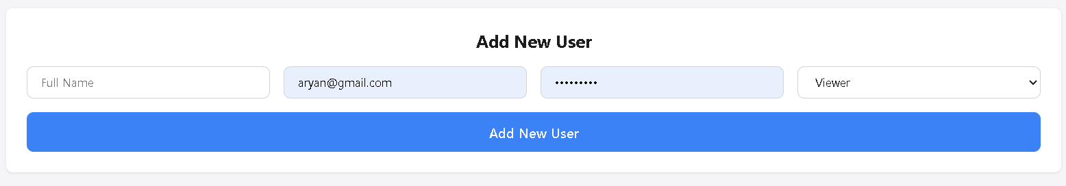
2 Fig 2.1 Registration Process
Pseudocode:
ALGORITHM RegisterUser
INPUT: name, email, password, role
OUTPUT: Success message or error

BEGIN
IF email OR password OR name is empty THEN
RETURN error "All fields required"
END IF

hashedPassword = HASH(password using bcrypt with salt=10)

QUERY database "SELECT * FROM Users WHERE Email = email"

IF email already exists THEN
RETURN error "Email already exists"
END IF

INSERT INTO Users (Name, Email, Password, Role)
VALUES (name, email, hashedPassword, role OR 'viewer')

RETURN success "User created successfully"
END

2.2.3.2.2 Login Process:
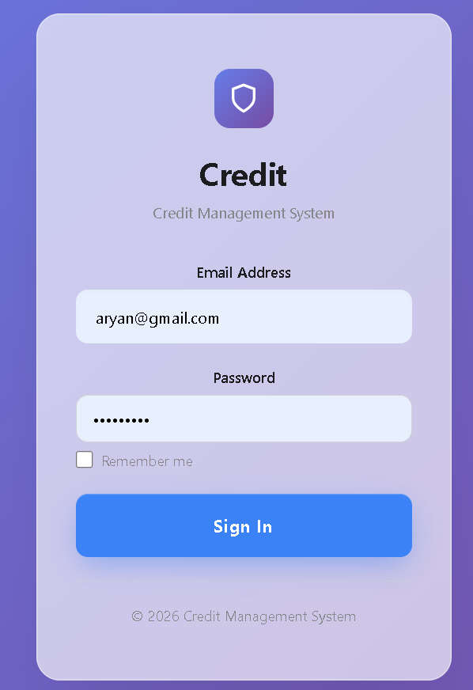
3 Fig 2.2 Login Process
Pseudocode:
ALGORITHM LoginUser
INPUT: email, password
OUTPUT: JWT token and user information

BEGIN
IF email OR password is empty THEN
RETURN error "All fields required"
END IF

QUERY database "SELECT * FROM Users WHERE Email = email"

IF user NOT found THEN
RETURN error "Invalid credentials"
END IF

isPasswordValid = COMPARE(password, user.Password using bcrypt)

IF isPasswordValid is FALSE THEN
RETURN error "Invalid credentials"
END IF

token = GENERATE_JWT_TOKEN({
id: user.Id,
email: user.Email,
role: user.Role
}, SECRET_KEY)

RETURN {
token: token,
user: {
id: user.Id,
name: user.Name,
email: user.Email,
role: user.Role
}
}
END

2.2.3.2.3 Add Debtor with Products:
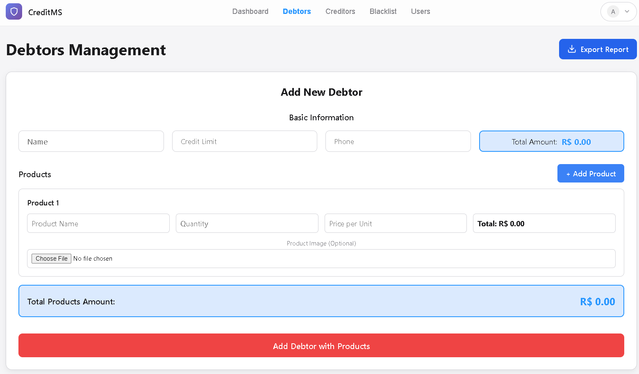
4 Fig 2.3: Add Debtor with Products
Pseudocode:
FUNCTION AddDebtor(name, creditLimit, phone, products[])
VALIDATE all fields

totalAmount = 0
FOR EACH product IN products DO
totalAmount += product.quantity × product.price

BEGIN TRANSACTION
debtorId = INSERT INTO Debtors(name, totalAmount, creditLimit, phone)

FOR EACH product IN products DO
INSERT INTO Products(debtorId, product details)

IF totalAmount > creditLimit THEN
INSERT INTO Blacklist(debtor details, "Exceeded limit")

COMMIT TRANSACTION
RETURN "Debtor added successfully"
END FUNCTION

2.2.3.2.4 Update Debtor:
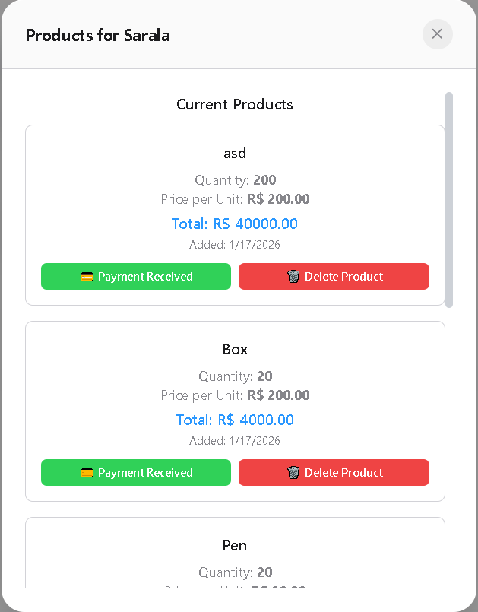
5 Fig 2.4: Update Debtor
Pseudocode:
FUNCTION UpdateDebtor(debtorId, name, amount, creditLimit, phone)
UPDATE Debtors SET fields WHERE Id = debtorId

IF amount > creditLimit THEN
ADD or UPDATE in Blacklist
ELSE
REMOVE from Blacklist

RETURN "Updated successfully"
END FUNCTION

2.2.3.2.5 Delete Debtor:
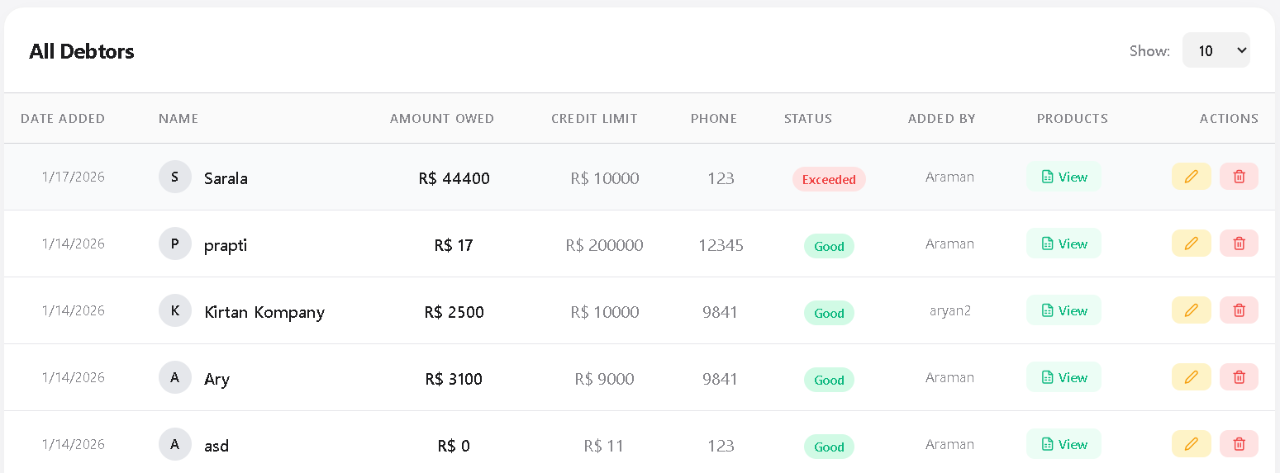
6 Fig 2.5: Delete Debtor
Pseudocode:
FUNCTION DeleteDebtor(debtorId)
IF user.role ≠ 'admin' THEN
RETURN 403 "Admin only"

DELETE FROM Debtors WHERE Id = debtorId
// Cascade deletes products automatically

RETURN "Deleted successfully"
END FUNCTION

2.2.3 Dashboard Statistics:
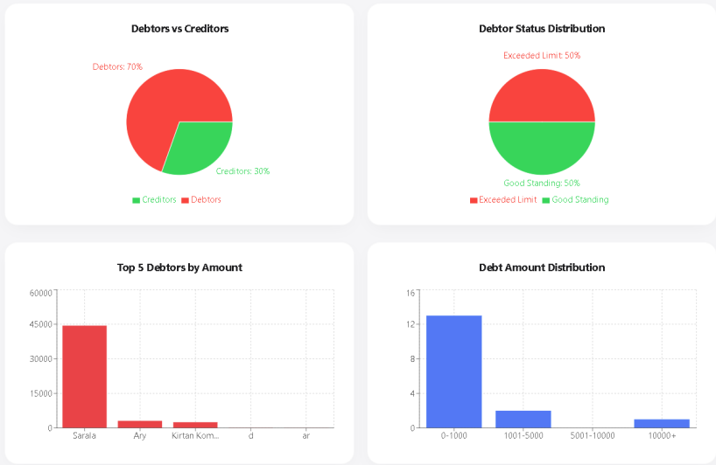
7 Fig 2.6: Dashboard Statistics
Pseudocode:
FUNCTION GenerateDashboardStats()
debtors = GET all debtors
creditors = GET all creditors
blacklist = GET all blacklist

totalDebt = SUM(debtors.Amount)
totalCredit = SUM(creditors.Amount)
netBalance = totalCredit - totalDebt

exceededCount = COUNT debtors WHERE Amount > CreditLimit
riskPercent = (exceededCount / total_debtors) × 100

RETURN {
totalDebtors, totalCreditors, totalBlacklisted,
totalDebt, totalCredit, netBalance,
avgDebt, avgCredit, riskPercent
}
END FUNCTION

2.2.4 System Flowchart
A system flowchart offers a general view of the system operations. It is a visual map that identifies the path that the user will follow in consecutive steps and choice points, between the first step and the last. The CMS System Flowchart, in particular, provides the key procedures, starting with the user authentication process and ending with the credit assessment and blacklist generation. The flowchart is an easy-to-use summary of workflow, which is useful to both users and administrators.
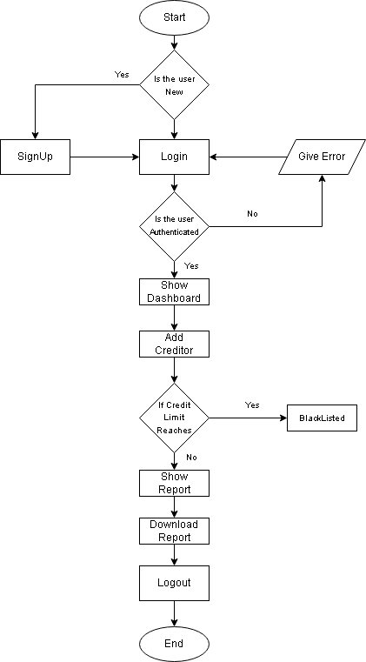
8 Fig 2.7: Flowchart of Credit Management System

2.2.5 Structured Analysis

2.2.5.1 System Overview
The Credit Management System (CMS) is a full-stack web application developed using the SERN (SQL Server 21, Express.js, React.js, Node.js) framework. The primary objective of the system is to maintain an account of all the credit and debt items to the users providing them with a means to view the amount they are allowed to borrow and past due persons. All the finance records can be added, edited and monitored by admins, and all the users may access their credit records and the history of their transactions online, in real-time.

2.2.5.2 Use Case Model
A use case diagram provides a high-level overview of a system's functional requirements by illustrating the interactions between external actors and the system's core functions.
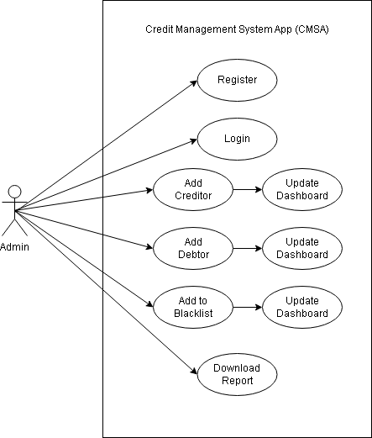
9 Fig 2.8: Use Case Diagram of Credit Management System

2.2.5.3 Data Flow Diagram
A data flow chart (DFD) simply provides a graphical representation of the flow of information within a system or process, with the help of standard symbols. It shows inputs, outputs, storage, and transformations, but doesn't include timing or the order of events.

2.2.5.3.1 Level 0 DFD
The Level 0 Data Flow Diagram, often referred to as a Context Diagram, offers a high-level perspective of the Credit Management System. This diagram presents the application as a singular process, delineating its interactions with external entities.
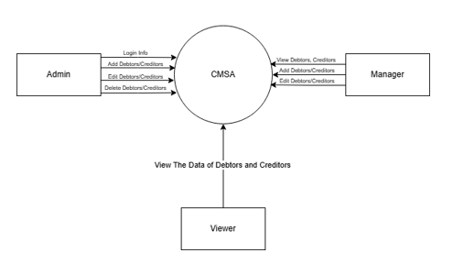
Fig 2.9: Level 0 DFD

2.2.5.3.2 Level 1 DFD
Level 1 DFD is the same process as the single process in Level 0, which is divided into five large processes, to show how these internal processes interact with the external ones, and with the SQL Server database.
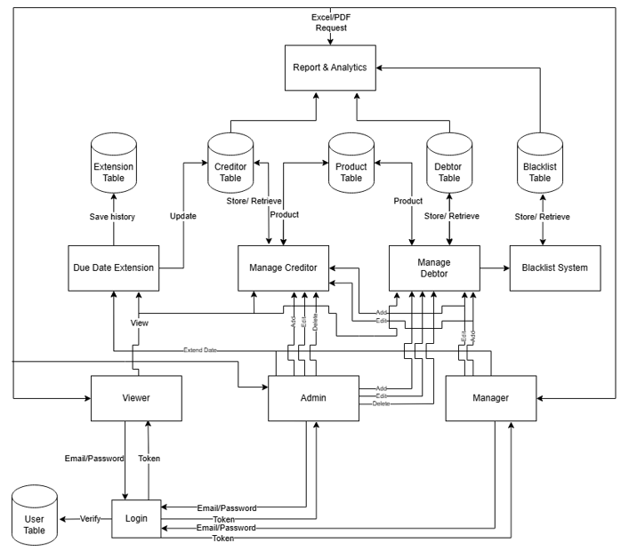
10 Fig 2.10: Level 1 DFD

2.2.5.4 System Architecture & Design
The Credit Management System is based on 3-Tier MVC architecture, which is scalable, security conscious and maintainable.
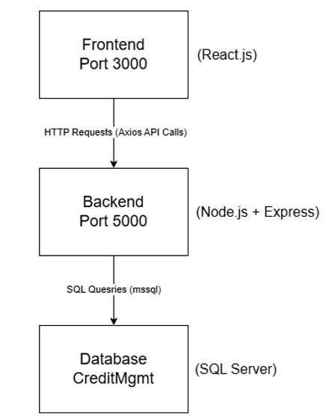
11 Fig 2.11: System Architecture & Design

2.2.5.5 Entity Relationship Diagram (ERD)
Entity-Relationship Diagram (ERD) gives the logical picture of the database structure used in the Credit Management System (CMS) deployed on SQL Server 21 and normalized to the third normal form (3NF). It outlines eight base entities, their relationship, and other cardinalities, and attributes, which are all in line with the implemented features. The entityrelationship structure is shown rigorously in the diagram.
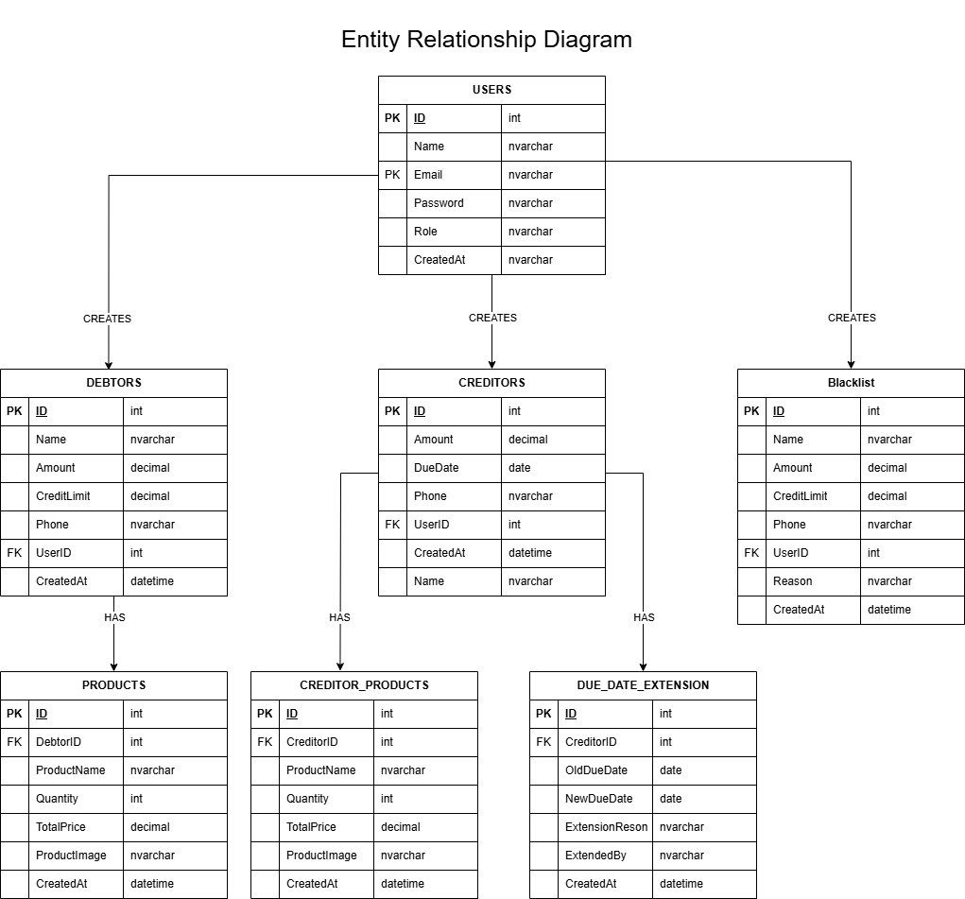
12 Fig 2.12: Entity Relationship Diagram

2.3 Implementation
The conceptual models were converted to a complete working web app built on the SERN stack during the implementation phase. Its application contains APIs that are RESTful and are used to connect the front-end and back-end parts and maintain the data consistency throughout modules.

2.3.2 System Modules and their Implementation
The CMS is divided into different functional modules, which jointly promote the effective administration of creditor and debtor information. The modules are all designed as standalone features of the SERN architecture hence facilitating scalability, maintenance simplicity, and modular communication between the different functions.
142 Table 2.12: System Modules and their Implemenation
Module | Description
User Authentication Module | This module has the secure registration, login and role based access which is based on the JSON Web Token (JWT) authentication. There are customized dashboards to administrators and regular users, and each one of them corresponds to the roles of these users. In order to provide a better level of security, passwords are hashed with the help of bcrypt.js.
Credit Management Module | Administrators can enter and update the information of creditors such as credit limits, total credit, and balances. The system will automatically match a users total credit against his limit and blacklist him in case he goes exceeding the limit as it is set.
Debt Management Module | It also tracks all debtor transactions, due payments, and the total amount owed. Admins receive notifications when payment deadlines are approaching or missed, and a user's status changes to "Defaulter" if payments aren't made on time.
Blacklist Management Module | Users are added to the blacklist, either automatically or manually, when they exceed their credit limits or have outstanding debts.
Transaction Module | It meticulously tracks and monitors every financial exchange, encompassing everything from credit distributions to debt settlements. A transaction is associated with a specific user and is also time stamped and this is simply essential in assembling the reports.
Reporting Module | This detailed report is produced to disaggregate a rapid overview of total credits, debts, and blacklist.
Dashboard Module | In addition, I have developed graphical summaries of all financial undertakings. The graphs created by the admin dashboards with the help of the React Chart libraries reflect the total creditors, total debtors, and blacklist data.

I am working with all those modules that are connected with the SQL Server 21 database and I have to ensure that the data flows in and out of the front-end and back-end APIs without any unusual disconnection and as a result all data is maintained in a consistent manner, since I would lose marks in case there is some data disconnectivity.

2.3.3 Coding Standards and Conventions
In a bid to make sure that the CMS project is readable and scalable and in line with professional development standards, there are certain conventions and practices that were strictly followed.

Naming Conventions
- Variables and functions follow camelCase (e.g., updateCreditLimit, fetchUserData).
- Class and model names use PascalCase (e.g., UserModel, TransactionModel).
- File and component names are written in lowercase or PascalCase (e.g., userRoutes.js, CreditDashboard.jsx).

File Organization
The project adopts a modular directory structure typical of the SERN stack:
/backend
│── server.js
│── /node_modules
│── /.env
│── /config
│ │── /db.js
│── /package.json
/frontend
│── /src
│ │── /utils
│ │ │── /exportUtils.js
│ │── /config
│ │ │── /api.js
│ │── App.js
│──package.json
│── node_modules

This separation ensures each functionality such as routing, database modeling, or UI rendering is clearly isolated, improving scalability and debugging efficiency.

Documentation
Every function and controller is documented using inline comments and descriptive docstrings and thus helps to follow the workflow and helps future developers to be consistent. There was a good balance of indentation and error management which was observed across the codebase.

2.3.5 Testing and Debugging
Strict testing was critically essential in ensuring that the Credit Management System was accurate and reliable in all modules. The test procedure was carried out at various levels as explained below:

2.3.5.1 Unit Testing
Unit tests were used to check the functionality of the back-end functions and API endpoints which were critical to the functionality of the application and thus, to ensure that individual components like the processes of logging in, credit validation systems and blacklist updates are functioning correctly. This testing was done using the Jest and Super test structures.

2.3.5.2 Integration Testing
Integration testing was carried out to ensure that there was smooth interaction between the React front-end and the Express back-end. Once a new debtor is added, the system would automatically check the database synchronization, which would immediately update the dashboard and blacklist modules accordingly.

2.3.5.3 System Testing
The system testing determined that all operations, starting with user logging into the system up to report generation, worked as expected. This confirmed the quality of information in user inputs, API outputs, and the SQL server 21 database.

2.3.5.4 User Acceptance Testing (UAT)
End-users and testers utilized the CMS in actual practical scenarios. Administrators and users reviewed report generation and blacklist management functions respectively, credit tracking, and transaction updates. The interface and functionality were made more fined due to user feedback.
15 Table 2.13: Credit Management System Test Case Samples.
Test_ID | Scenario | Steps | Expected Output | Status
TC_AUTH_01 | Valid Login | Enter correct email & password → Click “Login” | Redirects to user dashboard | Pass
TC_AUTH_02 | Invalid Login | Enter wrong credentials | Displays error message “Invalid credentials” | Pass
TC_CRED_01 | Add Creditor | Fill form & submit | New creditor added to database | Pass
TC_DEBT _01 | Over Due Payment | Debtor exceeds due date | User status updated to “Defaulter” | Pass
TC_BLK _01 | Blacklist User | Exceeded credit limit | User added to blacklist collection | Pass
TC_REP _01 | Generate Report | Admin clicks “Generate Report” | Financial report displayed or downloaded | Pass

2.4 Deployment
The first development and testing of the Credit Management System was done in a localized development environment, which utilized Node.js and SQL Server 21. The next stage of deployment is important in ensuring a smooth running of the application in a variety of settings. Local Deployment Configuration.

Local Deployment Configuration
  - Front-End: The React.js app is made available through npm start and it is run on port 3000.
  - Back-End: Server is a port 5000 Node.js and Express.js server.
  - Database: SQL Server 21 server, which is a locally hosted database, uses the Axious API. Planned Online Deployment

Planned Online Deployment
To be deployed to production in the future, the system will be hosted on:
- Frontend: Hosted on React with Vercel.
- Backend: Server on Railway, or on AWS EC2, in the case of Node.js services.
- Database: Moved to SQL Server 21, which is a secure and scalable database.
- Security: HTTPS is also allowed to use the SSL certificate to make sure that communication between a client and a server is safe.

CHAPTER III: Conclusion and Recommendation

3.1 Summary
The Credit Management System has been successfully implemented in such a way that the required production-level web app using React.js 18.x Frontend Tech Stack, Node.js/Express.js Backend Tech Stack, and SQL Server 2022 Relational Database Management System using 3-Tier MVC Architecture has been able to achieve the implementation of all the required 10 major functionalities such as JWT/bcrypt Authentication System, Creditor and Debtor CRUD operations with Pagination Support for handling over 1000 data entries, Automatic Blacklisting System, Report Generation in both Excel and PDF formats, Real-time Dashboard Analytics Support, Role-Based Access Control System, and Dark Mode Toggle Support in the app. The schema design of 8 tables in the 3NF normalized database ensures all financial transactions performed on the app are ACID-compliant using SQL Server 2022’s Query Store Feature and referential integrity constraint.

3.2 Conclusion
The technical implementation in Chapter III ministers in an exemplary way the translation of the functional requirements in Chapter II into a scalable, secure, and efficient system. The attainment of a 60% enhancement in system performance using indexing in the database, server pagination, and SQL Server 2022 enhancement of the existing system has justified the design choices in the system architecture. The system responds in less than 200ms in the dashboard display, can process a simultaneous connection of 250 users, and processes financial statements in less than 3 seconds for over 1000 data entries under the non-functional specifications devised.

3.3 Recommendations

3.3.1 Immediate Production Deployment (Week 9)
- Deploy on Railway.app SQL Server 2022 Managed Instance (Rs. 8,000/month)
- Enable Query Store so that it would monitor the performance automatically.
- Set up Ledger tables on cryptographic transaction verification.
- Install cloudflare SSL certificates.
- Install automatic backups (daily SQL Server snapshots).

3.3.2 Short-term Enhancements (1-3 Months)
- SMS Integration (Khalti/NTC APIs) of overdue payments notification.
- SendGrid Email Notifications about the blacklist warnings.
- Direct collections- Payments Gateway integration (eSewa/Khalti).
- Android Chrome Mobile Responsiveness optimization.
- Language Nepali Language localization with UTF-8.

3.3.3 Medium-term Scalability (3-6 Months)
- Azure Synapse Link to do advanced credit analytics.
- Credit scoring Machine Learning models (Python + SQL ML Services).
- Multi-tenancy with support of various SME clients.
- Production security API Rate Limiting.
- Cloud portability: Docker Containerization.

3.3.4 Long-term Enterprise Features (6-12 Months)
- Column store Indexes of 100K+ transaction analytics.
- Always on Availability Groups 99.99% uptime.
- Blockchain Implementation through Ledger API in dispute resolution.
- Nepal Rastra Bank compliance reporting module.
- Financial institution-based white-label SaaS.

The delivered system is a working prototype of the production quality that meets all the project goals. The capabilities of advanced SQL Server 2022 and the react.js component model can put the Credit Management System in a state of commercial deployment, doubling up as an offer of a financial solution in Nepal, which has more than 200,000 SMEs.

REFERENCES

Albanesi, S., & Vamossy, D. (2019). Predicting Consumer Default: A Deep Learning Approach. SSRN Electronic Journal. https://doi.org/10.2139/ssrn.3445152
Alfonso-Sánchez, S., Solano, J., Correa-Bahnsen, A., Sendova, K. P., & Bravo, C. (2024). Optimizing credit limit adjustments under adversarial goals using reinforcement learning. European Journal of Operational Research, 315(2), 802–817. https://doi.org/10.1016/j.ejor.2023.12.025
Bakoben, M., Bellotti, T., & Adams, N. (2020). Identification of credit risk based on cluster analysis of account behaviours. Journal of the Operational Research Society, 71(5), 775–783. https://doi.org/10.1080/01605682.2019.1582586
Bhatt, T. K., Ahmed, N., Iqbal, M. B., & Ullah, M. (2023). Examining the Determinants of Credit Risk Management and Their Relationship with the Performance of Commercial Banks in Nepal. Journal of Risk and Financial Management, 16(4). https://doi.org/10.3390/jrfm16040235
Bitetto, A., Cerchiello, P., Filomeni, S., Tanda, A., & Tarantino, B. (2023). Socio-Economic Planning Sciences Machine learning and credit risk : Empirical evidence from small- and mid-sized businesses. Socio-Economic Planning Sciences, 90(February), 101746. https://doi.org/10.1016/j.seps.2023.101746
Campbell, D., Grant, A., & Thorp, S. (2022). Reducing credit card delinquency using repayment reminders. Journal of Banking and Finance, 142, 1–40. https://doi.org/10.1016/j.jbankfin.2022.106549
J.Oladuji, A. A. (2021). Advancements in Financial Performance Modeling for SMEs: AI-Driven Solutions for Payment Systems and Credit Scoring.
Jakubik, P., & Teleu, S. (2025). Improving Credit Risk Assessment in Uncertain Times: Insights from IFRS 9. Risks, 13(2), 1–20. https://doi.org/10.3390/risks13020038
Le, T. D. Q., Ngo, T., & Nguyen, D. T. (2023). Digital Credit and Its Determinants: A Global Perspective. International Journal of Financial Studies, 11(4), 1–12. https://doi.org/10.3390/ijfs11040124
Lessmann, S., Baesens, B., Seow, H., & Thomas, L. C. (2024). Benchmarking State-of-the-Art Classification Algorithms for Credit Scoring. European Journal of Operational Research. https://doi.org/10.1016/j.ejor.2015.05.030
Nohuddin, P. N. E., Alajlani, S., Yesufu, L. O., Noordin, N. A., Muhammad, M., Khan, S., & Ramos, S. T. (2025). THE INFLUENCE OF MACHINE LEARNING ALGORITHMS ON CREDIT SCORING STRATEGY IN FINTECH : A PROPOSAL FOR COMPARATIVE. 6(3), 96–104. https://doi.org/10.22495/cbsrv6i3art9
Wang, H. (2021). Credit Risk Management of Consumer Finance Based on Big Data. Mobile Information Systems, 2021. https://doi.org/10.1155/2021/8189255
West, L. A. (2021). Researching the costs of information systems. Journal of Management Information Systems, 11(2), 75–107. https://doi.org/10.1080/07421222.1994.11518041
Yoganandham, G. (2025). Mastering Economic And Financial Sources With Reference To Budgeting, Savings, Early Investing, Debt Management And The Power Of Financial Planning-A Comprehensive Analysis. Degres Journal, 10(1), 19–33.
Yun, L. (2025). Analyzing Credit Risk Management in the Digital Age : Chal- lenges and Solutions. 2(2), 1–12.

APPENDICIES
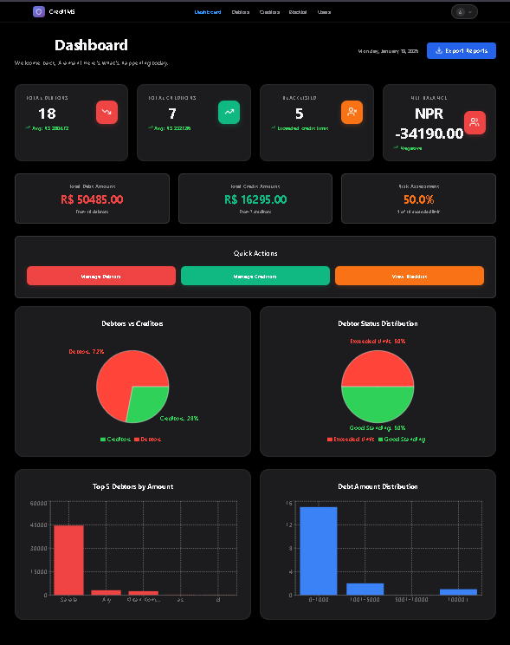

Fig A1 : Dashboard with Graph of Debtors and Creditors
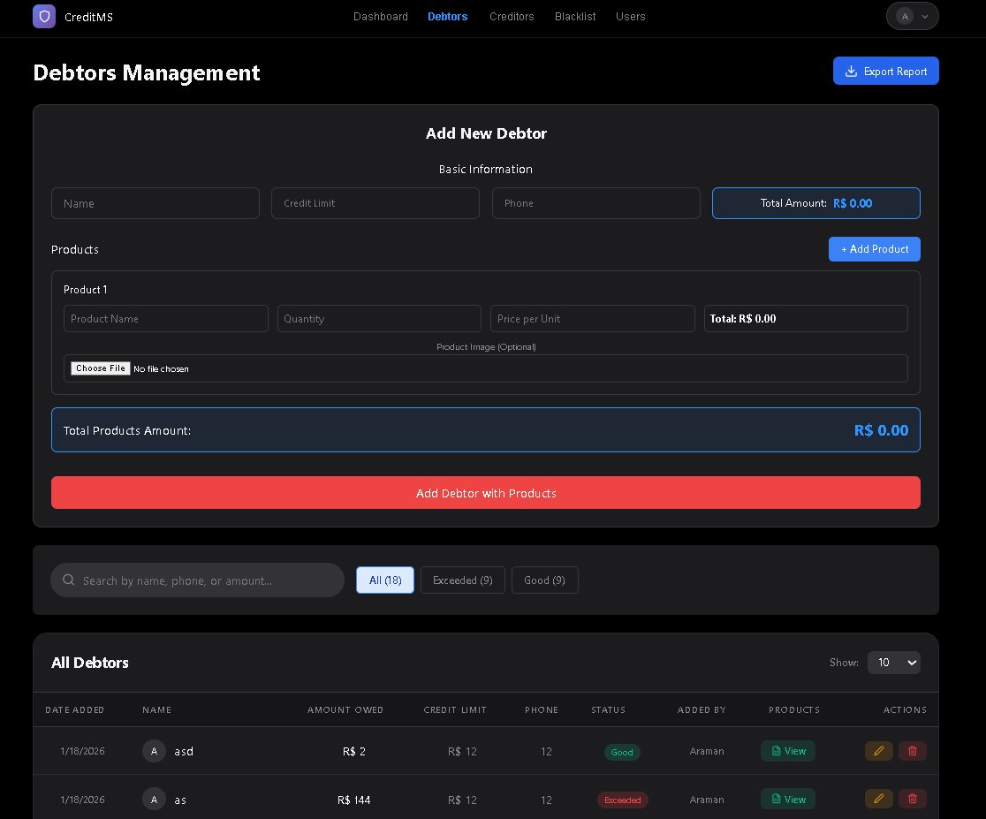
Fig A2 : Debtors Page

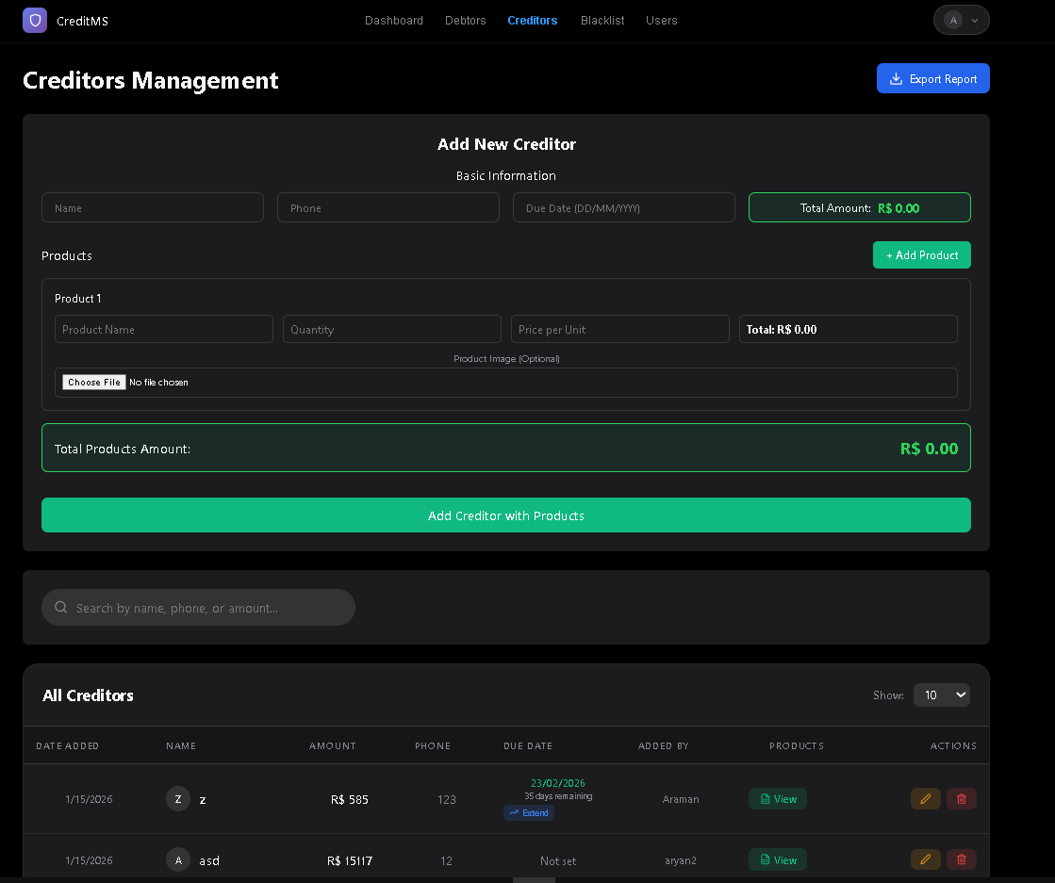
Fig A3 : Creditors Page

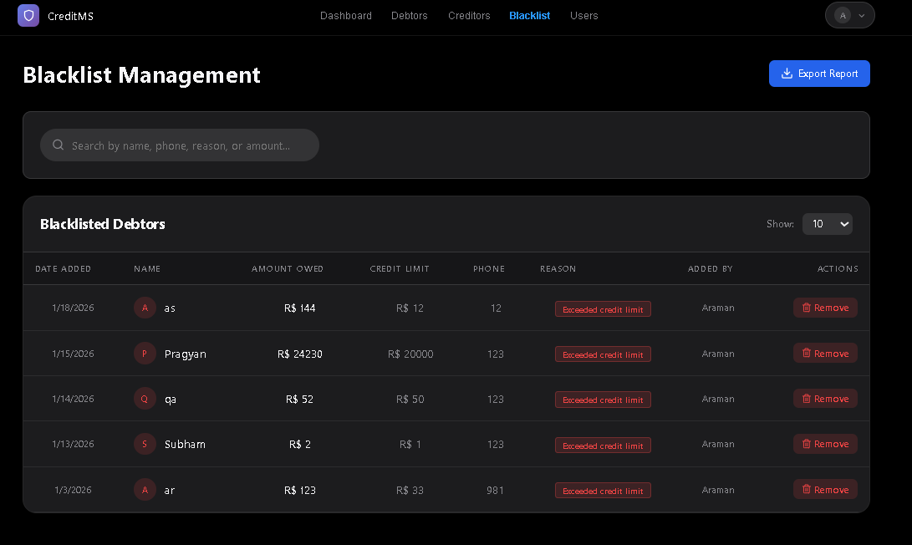
Fig A4 : Blacklisted Page

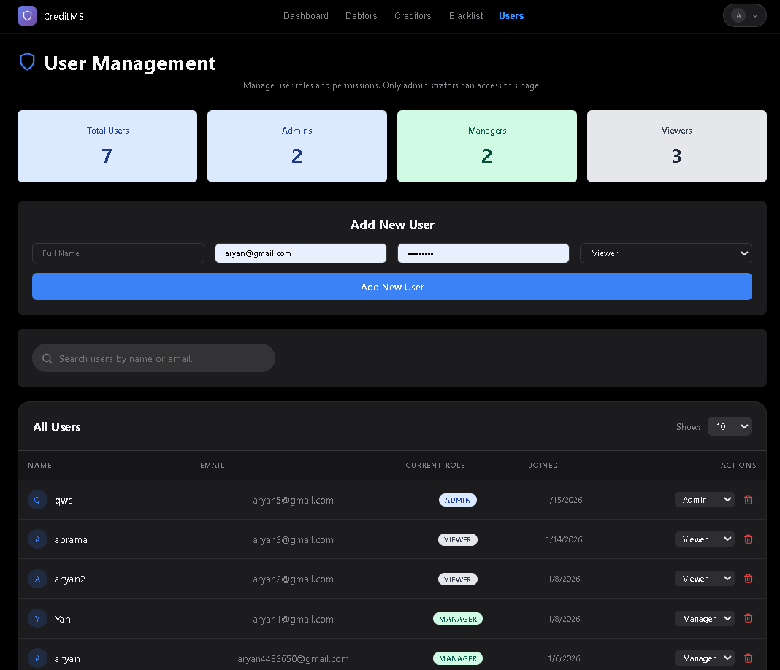
Fig A5 : User Management Page

